Exp no: 241901108
Name: T.Siva Sankari
Department: CSE-Cyber Security

NMAP LIVE HOST DISCOVERY

AIM:
To identify which IP addresses on a network are active (responding) using Nmap's host discovery features.

INTRODUCTION:
Nmap is a network scanning tool that finds hosts, open ports, and services.


Task 1: Introduction
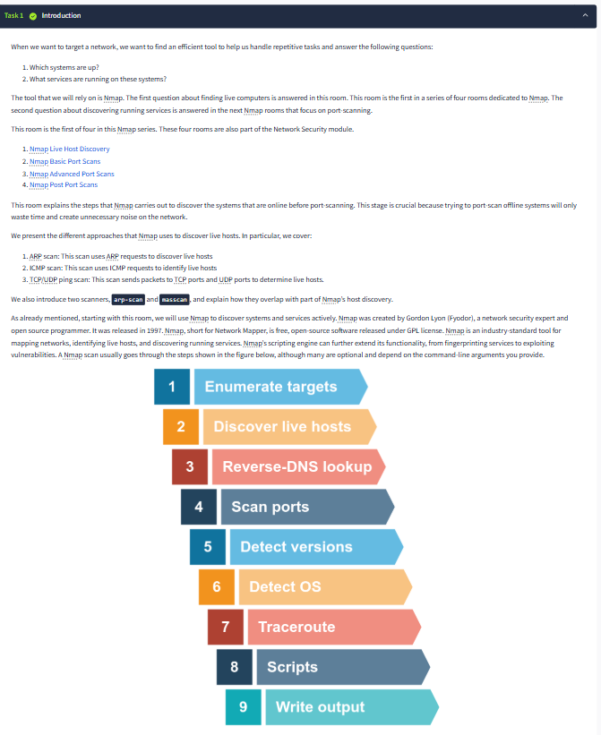
Task 2: Subnetworks

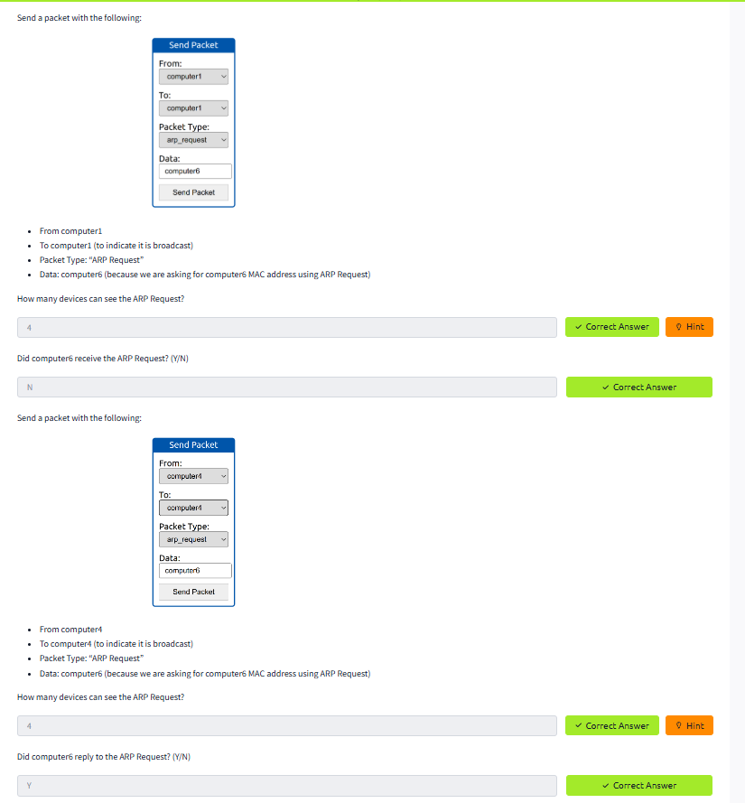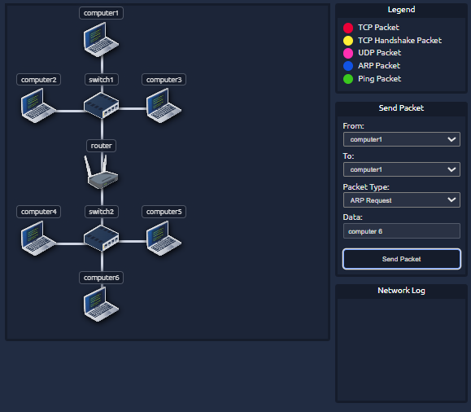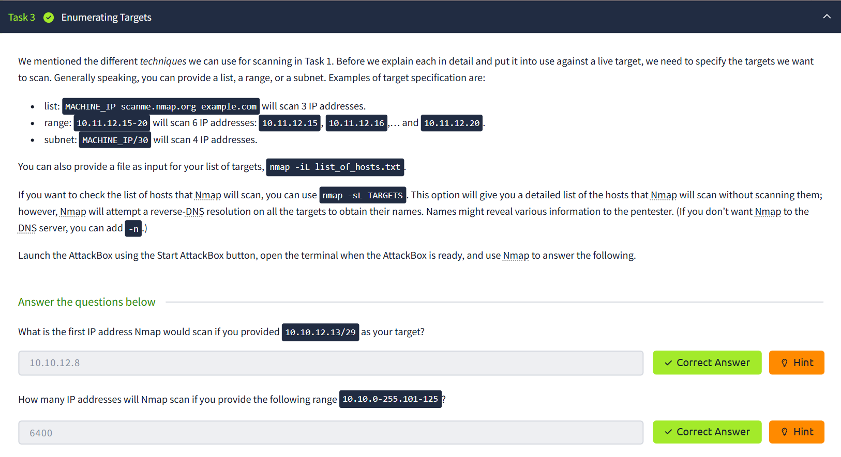
Task 4: Discovering Live Hosts
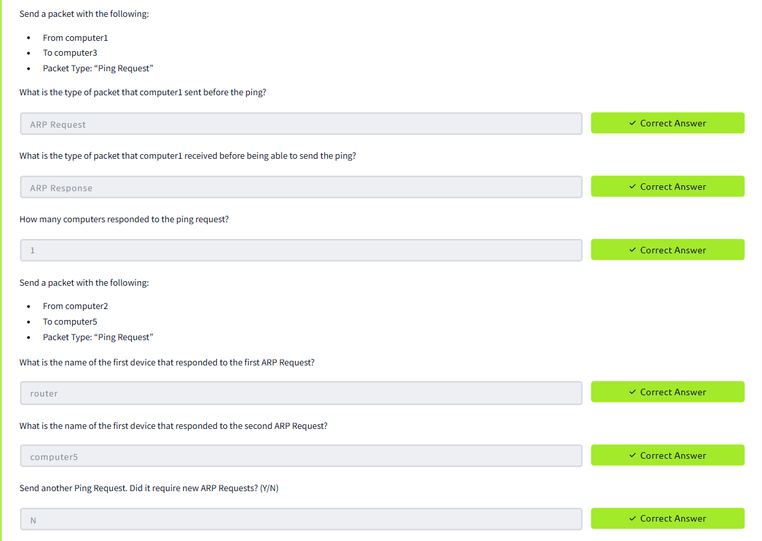
Task 5: Nmap Host Discovery Using ARP

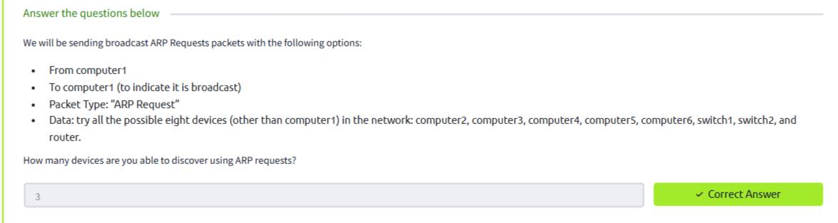
Task 6: Nmap Host Discovery Using ICMP
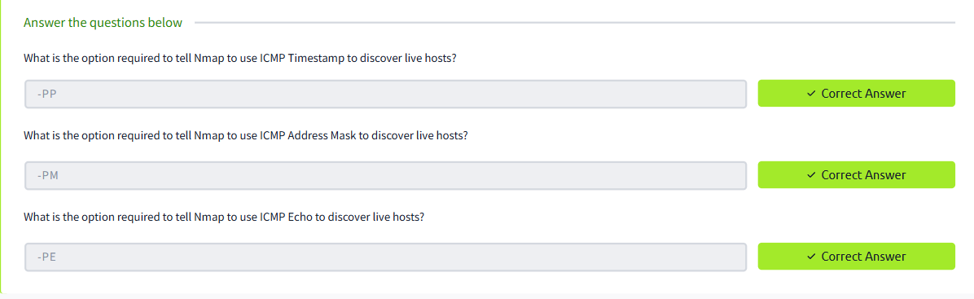
Task 7: Nmap Host Discovery Using TCP and UDP
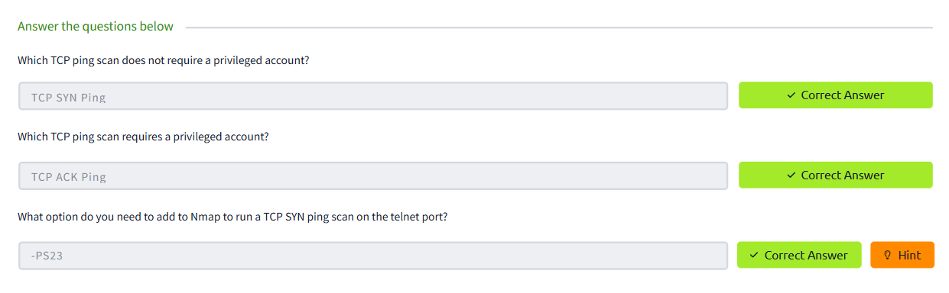
Task 8: Using Reverse-DNS lookup
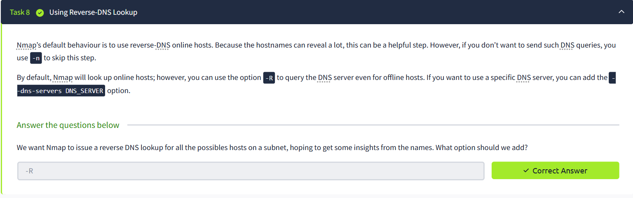

Summary:
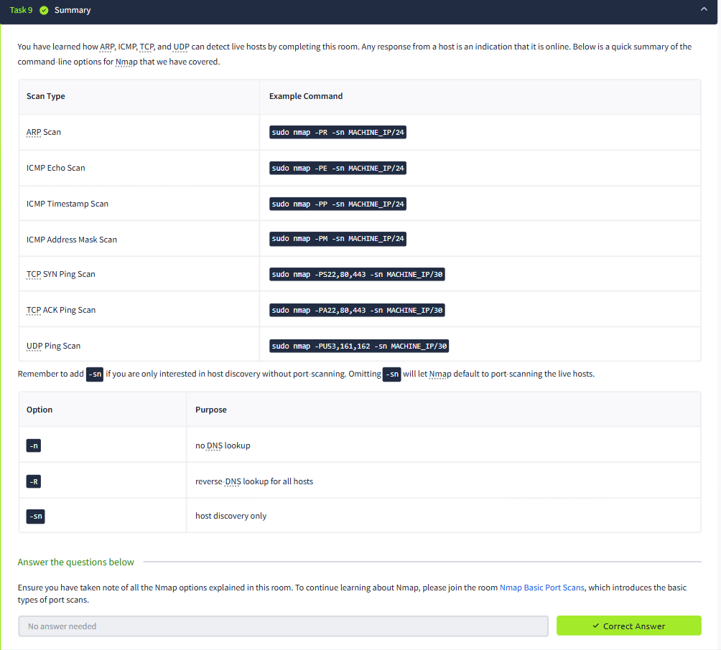

RESULT:
Thus Nmap was used to discover live hosts using ARP scan, ICMP scan, and TCP/UDP ping scan in TryHackMe platform.

